Memorandum of Understanding
for an International Cooperation Agreement
between
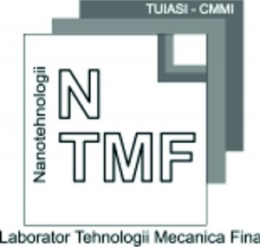  LFMT (Laboratory of Fine Mechanic Technologies,  (dumitrunedelcu.ro/laboratory-professor-dumitru-nedelcu-phd/)  Department of Machine Manufacturing Technology,  Faculty of Machine Manufacturing and Industrial Management,  “Gheorghe Asachi” Technical University of Iasi, Romania |   University Research Center of Western Macedonia TEMENUS  (https://urc.uowm.gr/)  Research Institute of Traditional Architecture and Cultural Heritage (RITACH)  Greece
In order to provide a mechanism for scientific and technical cooperation which are beneficial to LFMT and RITACH, hereby agree to enter into this Memorandum of Understanding (MOU).
The objective of this MOU is to establish a basic framework for conducting cooperative activities between LFMT and RITACH which be beneficial to the respective institutions. Such cooperation is expected to results in synergistic augmentation of the scope and expertise of each institution and in enhancement of scientific and technical knowledge.
The scope of cooperative activities between LFMT and RITACH shall primarily consist of the following: exchange the professionals (scientists & engineers); participation in research projects of mutual interest; cooperation in developing new projects; exchange of R&D & Technical information and research experience; join and promotion research activity; workshop and Symposium.
This MOU is non-binding and each cooperative activity shall be effective only after a written agreement is signed by LFMT and RITACH. Any such written agreement shall include a statement of work and information on duration, cost, intellectual property management, and other terms and conditions necessary for international cooperative activities.
LFMT and RITACH shall actively seek public and private funding to facilitate cooperative activities as stipulated in this MOU.

Understood and Agreed,
Date: June 10th, 2020 | Date: June 10th, 2020
Professor Dumitru Nedelcu, Ph.D  Signature:  Manager of LFMT  Department of Machine Manufacturing Technology,  Faculty of Machine Manufacturing and Industrial Management,  “Gheorghe Asachi” Technical University of Iasi, Romania | Associate Professor Panagiotis Kyratsis, Ph.D.  Signature:  Director of the Research Institute of Traditional Architecture and Cultural Heritage (RITACH)  University Research Center of Western Macedonia TEMENUS  University of Western Macedonia, Greece

